PDF Accessibility Process

Under Action Wizard, select Make Accessible and follow prompts to add accessibility elements to your PDF.

If not using Action Wizard, use the following steps:
  - Under Accessibility, choose Autotag Document
    - If the document is already tagged, choose to either overwrite tags or skip this step
    - 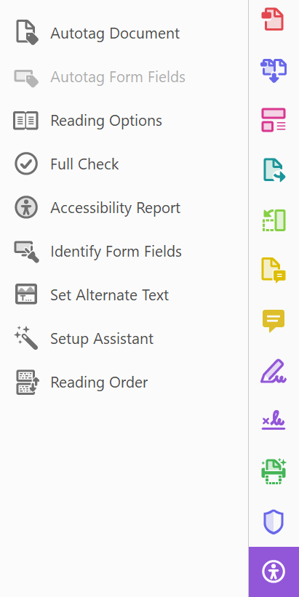
  - Set hyperlinks in your text
    - Select Edit PDF
    - Choose Link > Add/Edit Web or Document Link
    - Draw a box around text or image for link
    - Enter URL
  - Set ALTs (alternate text) for all images
    - Open the Tag Tree: View > Show/Hide > Navigation Panes > Tags
    - Right-click on Figure tags to open Properties
    - Edit Alternate Text
  - Set decorative or background images as Artifacts
    - Open the Tag Tree: View > Show/Hide > Navigation Panes > Tags
    - For Figures that should be decorative or background images, change the tag to read <Artifact>
    - 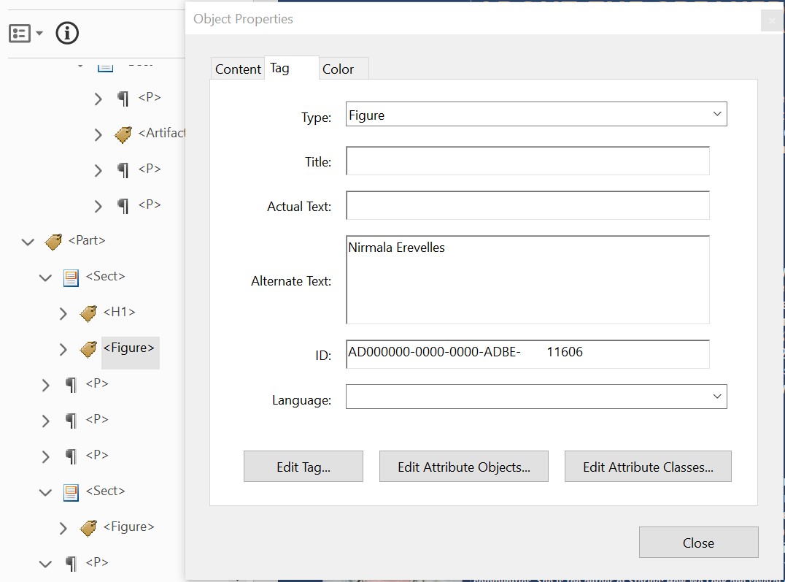
  - Include transcripts or textual descriptions for all purely audio or purely visual media
  - Use only captioned multimedia
  - Check the document for color dependence
    - Ask if the document uses color only to convey meaning
    - Example of color dependence: "All red items are required"
    - Example of no color dependence: "All red, bold items are required"
  - Check the document's color contrast using Color Contrast Analyser or Color Contrast Pal
    - Contrast should meet a ratio of 4.5:1 (foreground: background colors)
    - Adjust colors as necessary in original document
  - Ensure that the document has a title
    - Under File, choose Properties
    - Enter a Title for the document
    - A title might be the first heading or name of the document
    - 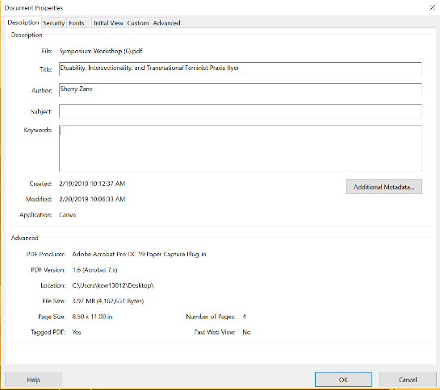
  - Set the document's language
    - Under File, choose Properties
    - Choose Advanced properties
    - Under Reading Options, set the document's language
    - 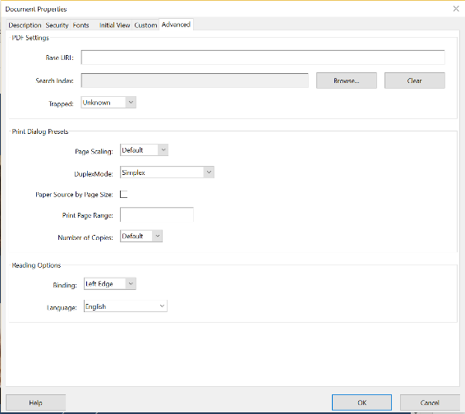
  - Ensure that headings are correctly set in the initial document and are tagged appropriately
    - Open the Tag Tree: View > Show/Hide > Navigation Panes > Tags
    - In Tags, move through heading tags (i.e. H1, H2, etc.) and paragraph tags
      - Are any tags that should be paragraphs labelled as headings?
      - Are any tags that should be headings labelled as paragraphs?
      - Are any headings the wrong heading level? (i.e. a heading level 1 is labelled as an H2)
      - Rule of thumb for headings: Typically, the bigger and bolder the heading is, the higher the heading level
    - 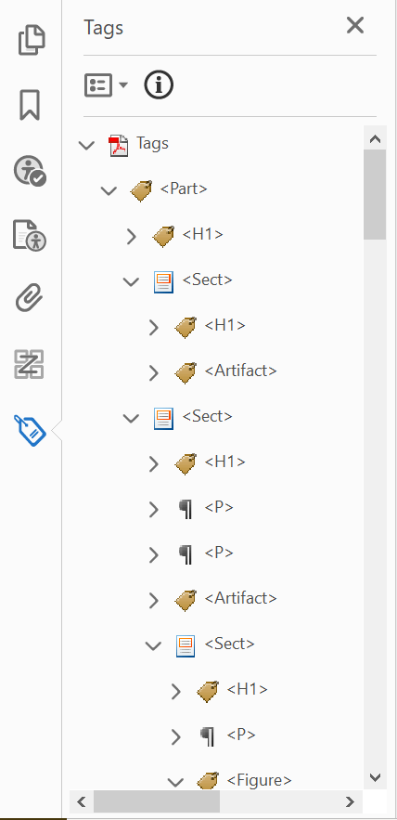
  - Set table headers using this document
  - Check Tag order
    - This is what a screen reader uses to determine how a document is read out
    - Check that the tag order matches the logical reading order
      - Rule of thumb for reading order: It should follow the order in which information appears visually
      - If the tag order does not match the logical reading order, click and drag on tags to reorder
      - For complex documents, you may have to add additional tags or delete tags
        - Add a tag by clicking on the tag above where you want the new tag to appear
        - Highlight information to be tagged
        - Right click on the tag above where you want the new tag to appear
        - Select Create Tag from Selection
        - 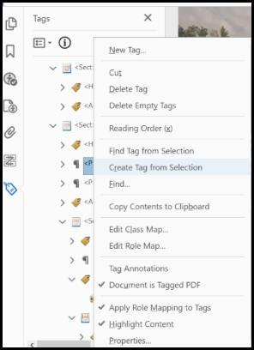
        - For images, you may need to create a new tag via the Reading Order panel
          - Open the Reading Order panel: View > Show/Hide > Navigation Panes > Order
          - Right click on any item and open Show reading order panel
          - Use the tool to draw a box around the area to be tagged and select the type of element
          - Right click on the new item and select Tag as… with the appropriate tag

  - Run a full accessibility check via the Accessibility tool
    - Fix any remaining problems
    - In the full check, Reading Order and Color Contrast will ALWAYS come up as requiring manual review. This is because a machine cannot determine if reading order is accurate or if color contrast is compliant
    - 