PowerPoint Accessibility Process
Use the Check Accessibility tool to determine accessibility issues with your PowerPoint and follow the prompts to fix issues. The Check Accessibility tool is located under File > Info > Check for Issues in Microsoft PowerPoint 2016 and under Review in Office 365.

If not using the Check Accessibility Tool, use the following steps:
- Use templates to set the slide’s correct reading order
  - PowerPoint will already have an idea of logical reading order based on the objects in a predefined layout
  - To adjust reading order: Under Home, click Arrange
  - Click Selection Pane
    - This will show you the slide’s tab order
    - Note: PowerPoint tab order reads from bottom to top; this means that the first item read by a screen reader will be the bottom item in the selection pane
  - 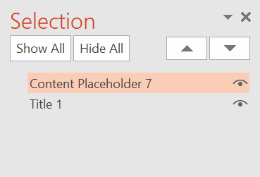
    - In the above image, the first item read would be Title 1
  - To modify templates, go to View and click on Slide Master
    - Slide Master allows you to edit template layouts
    - Use the selection pane to see the layout’s tab order
    - After modifying the layout, adjust the tab order to follow a logical reading order
- Under File, select Properties
  - Click Advanced Properties
  - Under Summary, add a Title property
  - The Title must be descriptive of the document’s content; it may be the same as the filename
  - 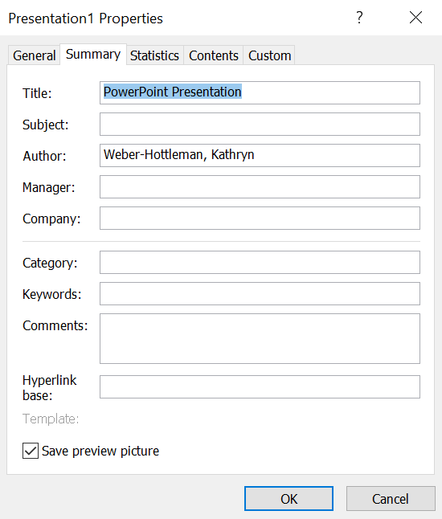
- If your PowerPoint is in a language other than English, select Review
  - Under Language, choose Language Preferences
  - Set the editing language and, if necessary, the display and help languages
  - 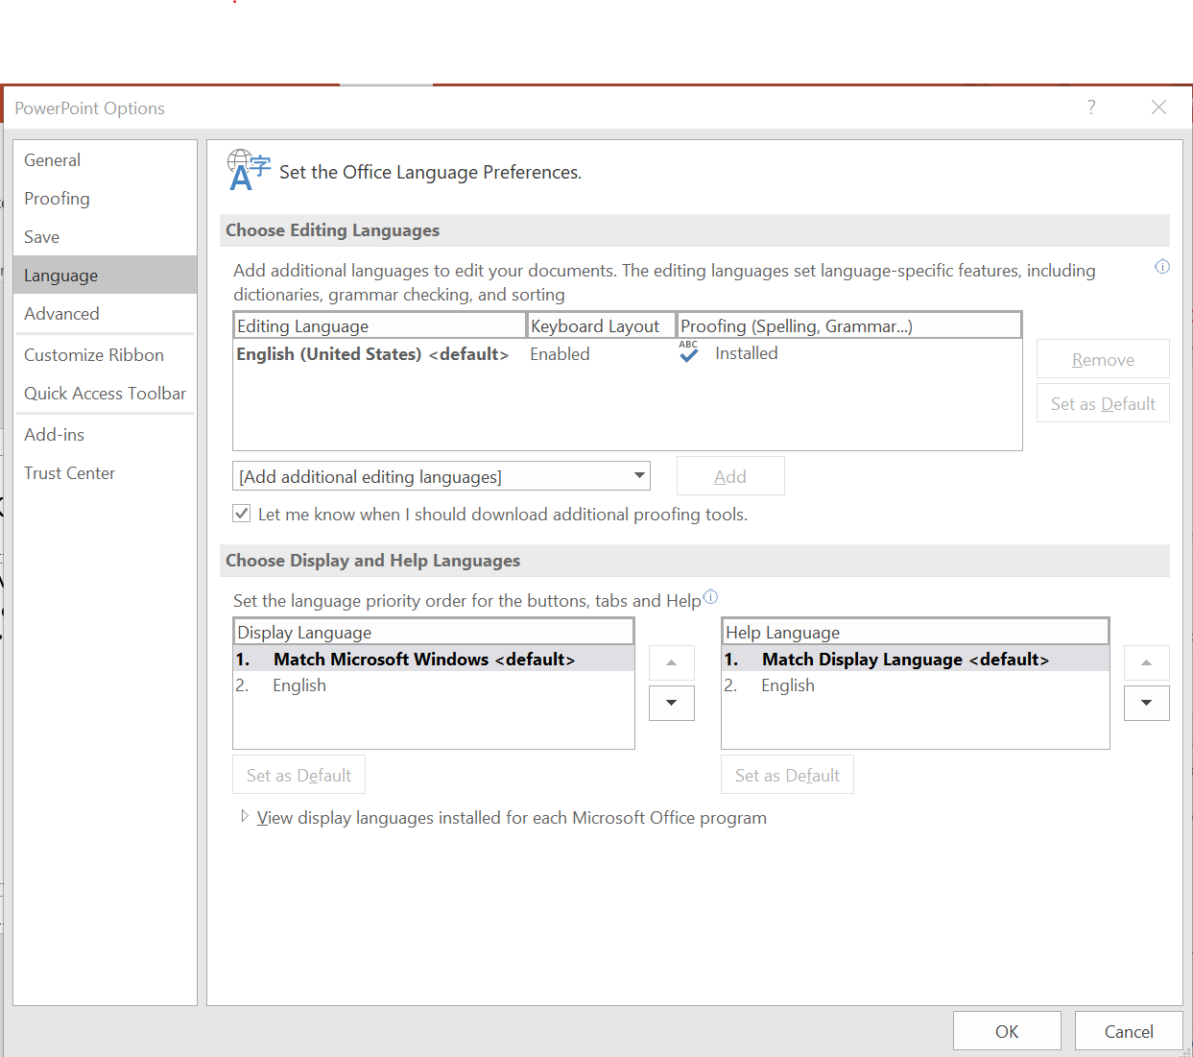
- Set links in text as hyperlinks with meaningful link text
  - Select text to be hyperlinked: Avoid “click here” and instead have text describe the link’s target
  - Under Insert, select Links
  - Click on Hyperlink
  - Add the desired URL
  - 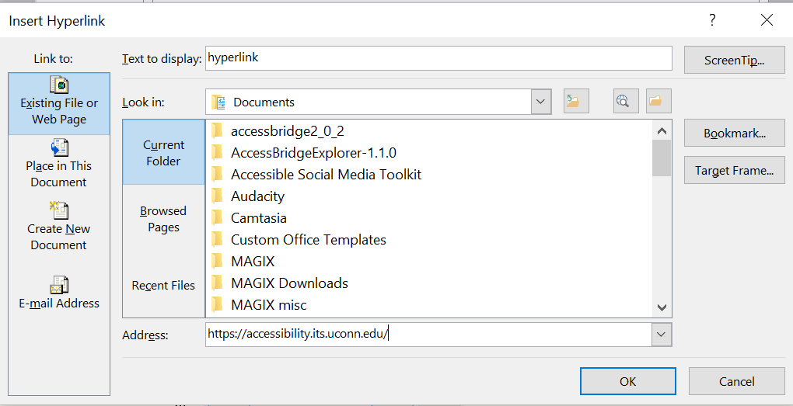
- Set ALTs (alternate text) for all images
  - Right click on any image in your document
  - Click Format Picture
  - Under the Size & Properties tab, choose Alt Text
  - Enter your alternate text for the image
  - 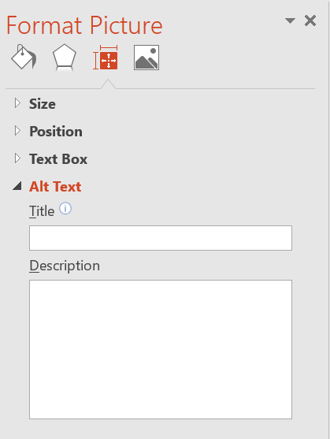
- Use an accessible font
  - Fonts with serifs, like Times New Roman, can be difficult to read for people with low vision or learning disabilities
  - Fonts like Arial and Calibri, sans serifs, are easier to read
  - Use a font size of at least 11 pt.
- Include transcripts or textual descriptions for all purely audio or purely visual media
- Use only captioned multimedia
- Check the document for color dependence
  - Ask if the document uses color only to convey meaning
  - Example of color dependence: "All red items are required"
  - Example of no color dependence: "All red, bold items are required"
- Check the document's color contrast using Color Contrast Analyser or Color Contrast Pal
  - Contrast should meet a ratio of 4.5:1 (foreground: background colors)
  - Adjust colors as necessary
  - Put text on solid backgrounds
    - Keeping text on solid backgrounds makes it easier to read for users who have vision impairments or learning disabilities
    - It can also help keep attention on the text, which is valuable for those with attention difficulties
- Minimize animations and eliminate flashing elements
  - Some users have disabilities that can be triggered by moving or flashing material
  - Simple animations and avoidance of flashing elements helps to make your slides usable for these individuals
- Set table headers
  - Click on the table
  - Under Design, ensure that Header Row and/or First Column is checked
    - 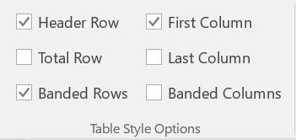
    - Use Header Row if headings are over columns
    - Use First Column if headings are by row

