Social Media Best Practices

Using Image Descriptions
Image descriptions are text captions for images on the internet. They can be put in plain text near the image (usually directly following it) or placed as alternate text in the HTML to be picked up by screen readers. It's simple to add them and it makes the internet more accessible for several groups.
As a final note, image descriptions are always separated from the rest of the text with symbols ({}, [], **, (), etc.) in order to announce their presence to screen readers.
There are two main categories of image description. For the purposes of this article, I've decided to classify them as sparse and lush.

Sparse
Sparse image descriptions are best suited for images presented with a particular focus in mind. They contain basic information on what is in the picture and call attention to the important aspects of it without detailing everything.
Pros: Shorter to write, get straight to the point, and don't clutter that point with unimportant details
Cons: Can remove reader autonomy (letting the reader decide what they think is important about the image), inappropriate for images that are just meant as visual art

Lush
Lush image descriptions are for when you want to describe everything. They are the best when presenting visual art without trying to point out anything in particular to your reader, or when you want the reader to decide what's important.
Pros: Detailed and give the exact picture
Cons: Take longer to write, can be confusing and overwhelming if overdone, can demonstrate author bias

General Tips
- Disable automatically-playing GIF files (some fast-playing GIFS can induce seizures. This will be under the same accessibility settings where you enabled alternate text).
- Write the word [LINK] before linking to another website. This may assist someone with a screen-reader in skipping the reading of a long link if they are uninterested in it.
- Capitalize the first letter in each word of a hashtag. It makes the hashtag easier to read for someone with a visual disability or a learning disability. Additionally, some screen-readers can detect individual words in a hashtag if the first letter is capitalized. If not, it will read each individual letter, which can create an internal spelling bee in your brain!
- If you cannot find a gif with alternate text, consider saving it as a still image file or writing a description of the gif.
  - Example One: “FYI: If you try to shake my hand during flu season, I may lysol you.” Two lines later, the following is written in brackets to illustrate the gif: “gif: Sheldon Cooper of Big Bang Theory sprays everything with Lysol.”
    - 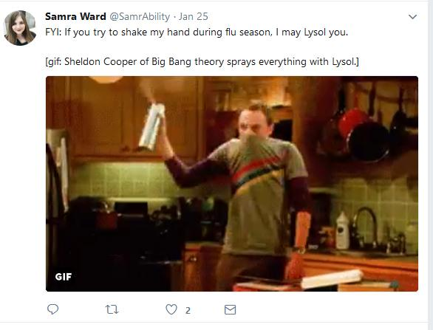
    - Example Two: “If you feel you may be having an anxiety attack then it might be a good time to do a breathing exercise just to slow it down a bit. [enter twice] [gif showing shapes expanding for 5 seconds with the text Breathe In followed by shapes collapsing for 5 seconds with the text Breathe Out]”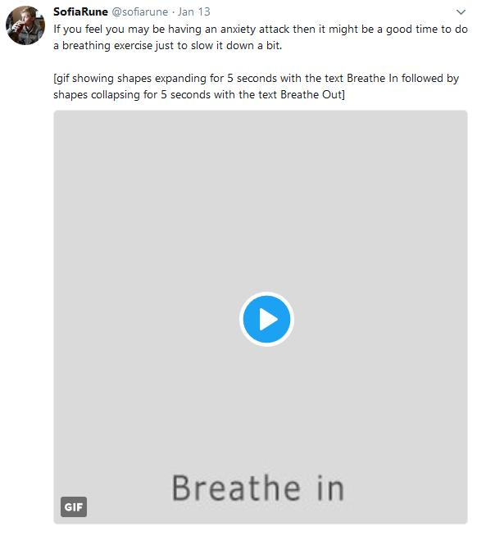

Facebook

On a computer or iOS device, you can embed alternate text into a photo. Facebook recommends using the following process:
- Click Photo/Video at the top of your News Feed.
- Select the photo you want to add.
- Click Edit Photo, then click Alt Text.
- The automatically generated text will be shown on the left side of your photo. Click Override generated alt text to edit it.
- Write your alt text in the box. To change back to the automatically generated text, click Clear.
- To save your alt text, click Save in the bottom right.

To change the alt text of a photo after you've posted it:
- Click the photo to open it.
- Click Options in the bottom right and select Change Alt Text.
- Click Override generated alt text or change the alt text in the text box. You can also click Clear to change your edited alt text back to the automatically generated text.
- Click Save.

On an Android device, there are 2 main styles for providing alternate text:
- Alternate text that describes the picture in the initial post
  - If you provide the alternate text in the initial post, we recommend placing the text in brackets and/or writing the words “Alternate text” prior to your description. This will allow users who use a screen-reader the opportunity to prepare for a description of an image.
- Alternate text in the comments.

In-post Alternate Text
A great example of using in-post alternate text may be found on the Joshua Tree National Park’s Facebook page.
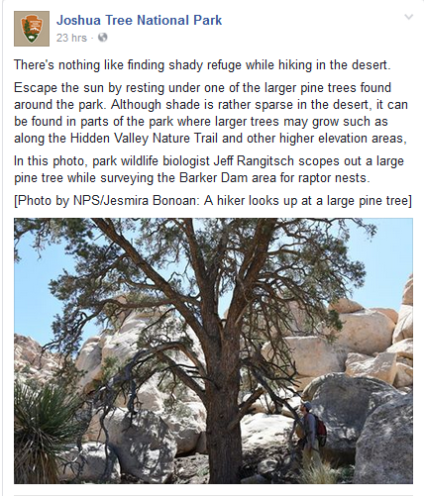

Alternate Text in Comments
If you switch between the two styles of alternate text on Facebook, you may wish to add “alternate text in comments” to your post. You will also want to make sure that your comments are shown in chronological order. To change your comments to chronological order, go to the bottom of your post and then click the word chronological or top comments. This will be next to the names of people who have liked your post. Make sure the checkmark is next to the word “chronological” instead of “top comments.” Below is a screenshot of this toggle setting.

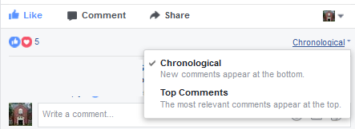

For an example of alternate text in the comments section, please refer to this post from the UGA Disability Resource Center, which may be found at this link (www.tinyurl.com/AltTextComments), or in the screenshot below, which has alternate text.

To add captions to Facebook videos, Facebook recommends the following process:
- Click Photo/Video at the top of your timeline or News Feed.
- Choose a video from your computer, then click Post.
- We'll notify you when your video is ready to view. Click the notification or the gray date and time at the top of the post on your News Feed or timeline.
- Click at the bottom and select Edit Video.
- Click Choose File below Upload SRT files and select a .srt file from your computer.
- Click Save.
Learn more about captioning Facebook videos and adjusting captions' appearance. You can also use settings to always show captions on Facebook videos.

Twitter

Enabling Alternate Text: Twitter Website and Official Applications
To enable alternate text for tweets using the official Twitter website or applications, follow the instructions at the following link: https://support.twitter.com/articles/20174660#. Supported applications include: Twitter for iOS, Twitter for Android, Twitter for web (www.twitter.com), VoiceOver for Twitter on iOS, Talkback for Twitter on Android, VoiceOver for Mac with twitter.com, JAWS for Windows Screen Reader with twitter.com, and NVDA screen reader for Windows with twitter.com.

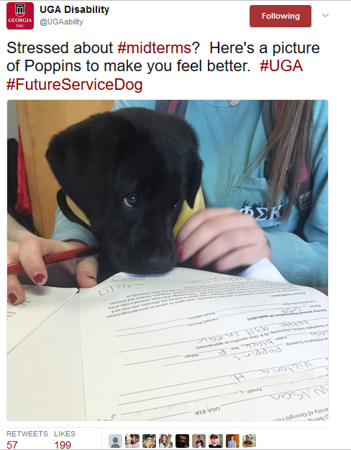
Sample Tweet: Alternate Text
Visible Text: @UGAability: Stressed about #midterms? Here’s a picture of Poppins to make you feel better. #UGA #FutureServiceDog

Hidden Alternative Text: Black lab puppy wearing a guide dog foundation vest peers at service animal registration paperwork

Retweeting Others’ Posts
Because alternative text is not easily visible on twitter, check before retweeting someone else’s post that has an image. To check on a Windows computer, right click the image and click “view image info.” A dialog box will pop up, and there will be a section entitled “associated text.” If a custom alternative text has been written, it will appear in that section.

Retweeting: Quoted Tweet
A flyer without accessible text was posted with the comment “Let’s be real...we all need this! Free workshop begins January 23.” Because the flyer did not have alternative text, a student who uses a screen reader would not know that this was a stress and anxiety workshop or where it meets. When retweeting, the user quoted the tweet and added “Stressed about classes? Starting January 23, join the @UGAHealthCenter On Mondays at 12:30 for a stress & anxiety workshop in Ramsey 213!” This provided access to information for a screen-reader user while also sharing an already-popular post.

Instagram
You can use alternate text in your Instagram photos to create a more inclusive experience for all users. To add alternate text to an image, use the following process:
- Click + to add photo.
- Select the photo you want to add.
- On the Share page, select Advanced Settings.
- Under Accessibility, choose Write Alt Text.
- Input your alt text.
- To save your alt text, click Save in the upper right corner.

To change the alt text or add alt text to a photo already posted:
- Choose the image you would like to edit and select the menu in the upper right corner.
- Choose Edit.
- Select Edit Alt Text. This will appear on the image, next to Tag People.
- Tap the check once your alt text is complete.

Duplicating Information
- Sometimes no alternate text is needed: Comment provides a pretty clear picture
- Important to not get so entrenched into the idea of providing alternate text that you are providing duplicate information

Example of duplication
Comment- Catching the sunset tonight at the beach. It is beautiful! #AllTheColors #Sunset
Alternate Text: Beautiful sunset at the beach

Adding Captions to Videos
While Instagram does not support closed captioning, like Facebook does, it is still possible to point viewers to accessible videos. One suggestion is to post a link to another site that has a captioned version, like YouTube or Vimeo, with your Instagram video. Another suggestion is to use a third party provider to create open captions, captions that cannot be turned off, and post the video with open captions. Either way, you are providing a more accessible experience for users with disabilities.

Adapted from: Ward, S. B., & Ashe, C. E. (2017, May 1). The Student Affairs Accessible Social Media Toolkit. Retrieved from https://drive.google.com/open?id=0B_-ZfCP7Aqp2RFRaRFQ2U1RTYXM

