Email Accessibility Process: Microsoft Outlook
- If your email is in a language other than English, select Review
  - Click Language Preferences
  - If the language of your email is other than the default (English), add additional editing languages and set the email's language
  - 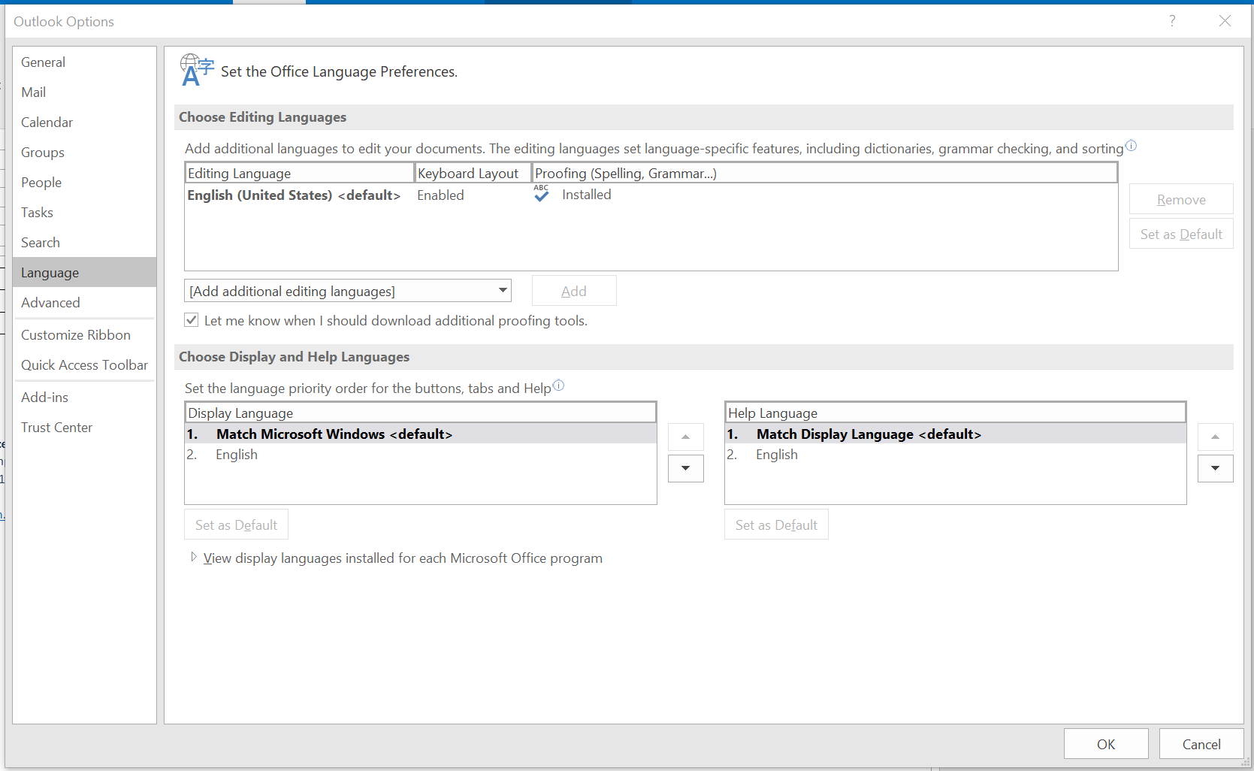
- Use predefined heading styles instead of bold, italics, or underline to set apart headings
  - In your email, under Styles, select the heading level you would like your text to be
  - Use heading styles to determine heading levels for your email
  - Rule of thumb for headings: Typically, the bigger and bolder the heading is, the higher the heading level
  - Change the appearance of the heading style
    - Choose the heading style you would like to change
    - Right click on the heading style
    - Click on modify
    - Change the style and save
    - 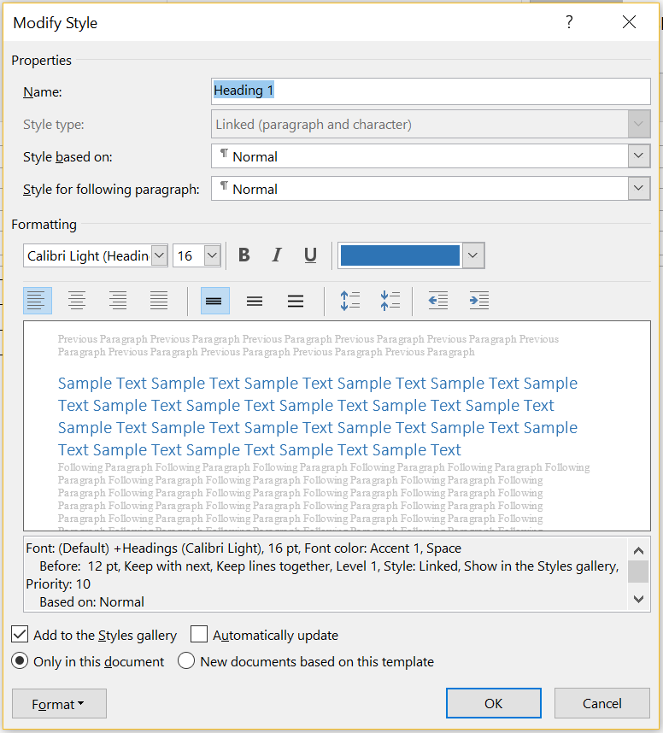
  - Avoid hitting Enter or Return to create extra space after your heading
    - Instead, highlight text after which you want the space
      - Right click on the text
      - Click Paragraph
      - Increase the space after the paragraph
      - Click Ok
      - 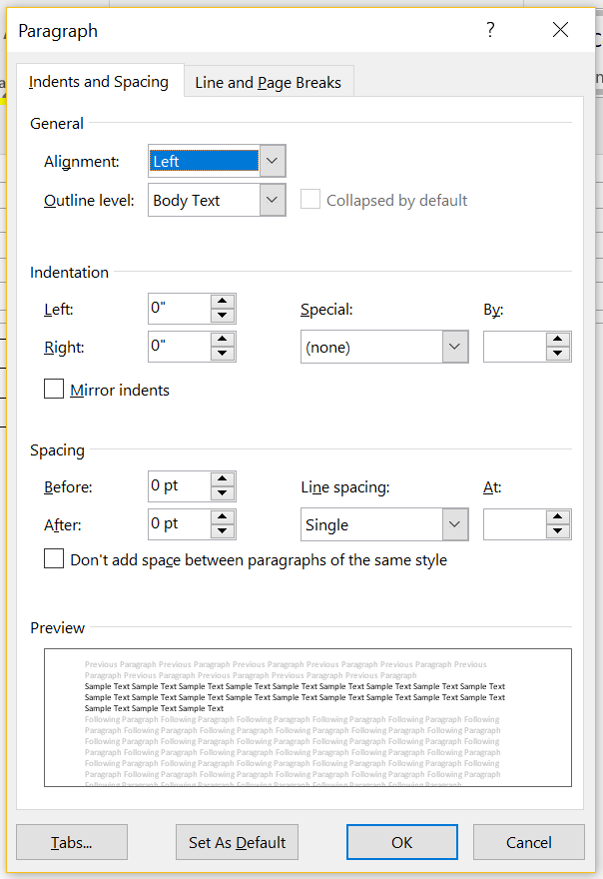
  - To apply a heading style to all similarly styled text, click Select
    - Choose Select all text with similar formatting
    - Click on the desired heading
- Set links in text as hyperlinks with meaningful link text
  - Select text to be hyperlinked: Avoid “click here” and instead have text describe the link’s target
  - Under Insert, select Links
  - Click on Hyperlink
  - Add the desired URL
  - 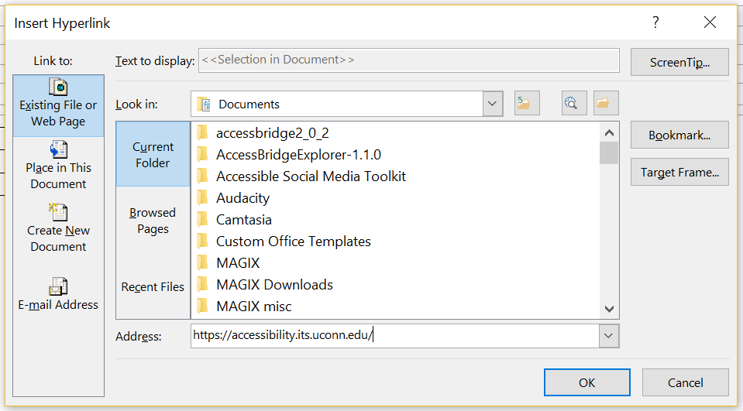
- Set ALTs (alternate text) for all images
  - Ensure that all of your image alignments are set to In line with text
  - Right click on any image in your email
  - Under Format Picture, select Layout and Properties
  - Enter your alternate text for the image in the Description box
  - 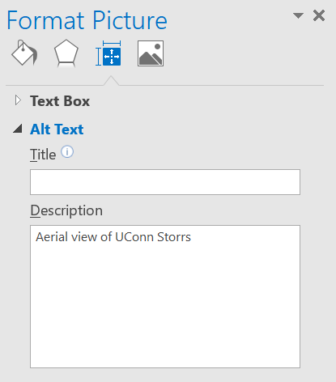
- Use an accessible font
  - Fonts with serifs, like Times New Roman, can be difficult to read for people with low vision or learning disabilities
  - Fonts like Arial and Calibri, sans serifs, are easier to read
  - Use a font size of at least 11 pt.
- Include transcripts or textual descriptions for all purely audio or purely visual media
- Use only captioned multimedia
- Check the document for color dependence
  - Ask if the document uses color only to convey meaning
  - Example of color dependence: "All red items are required"
  - Example of no color dependence: "All red, bold items are required"
- Check the document's color contrast using Color Contrast Analyser or Color Contrast Pal
  - Contrast should meet a ratio of 4.5:1 (foreground: background colors)
  - Adjust colors as necessary
- Set table headers
  - Click on the table
  - Under Design, ensure that Header Row and/or First Column is checked
    - Use Header Row if headings are over columns
    - Use First Column if headings are by row
    - 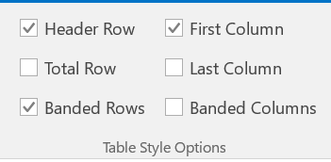
- Use predefined lists
  - Either before or after entering text, select the bulleted or numbered list icons
  - This will produce a programmatically-defined list
  - 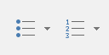

Making an Email Accessible: Outlook Office 365
- Next to Discard, click the 3 dots to show more email options
  - Select Check for accessibility issues
  - Follow prompts to make your email more accessible
  - 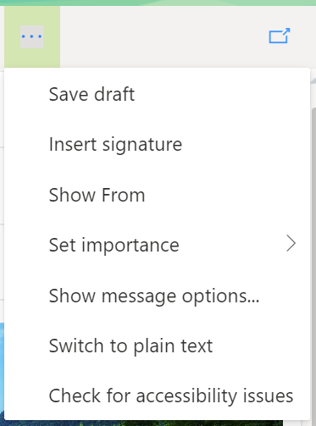
- Set links in text as hyperlinks with meaningful link text
  - Select text to be hyperlinked: Avoid “click here” and instead have text describe the link’s target
  - Next to Quote ", click the 3 dots to show more email options
  - 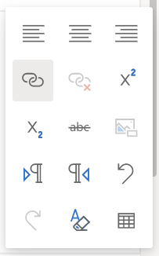
  - Click on Hyperlink
  - Add the desired URL
  - 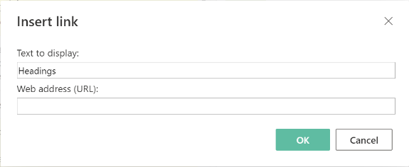
- Set ALTs (alternate text) for all images
  - Ensure that all of your image alignments are set to In line with text
  - Right click on any image in your email
  - Click Add alternate text
  - Enter your alternate text in the box provided
  - 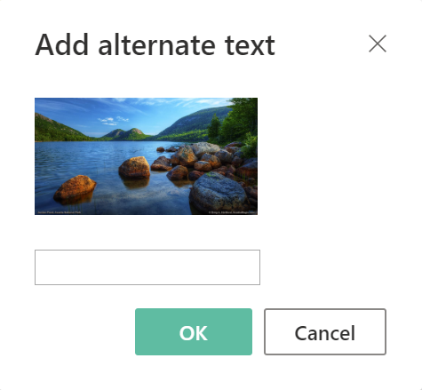
- Use an accessible font
  - Fonts with serifs, like Times New Roman, can be difficult to read for people with low vision or learning disabilities
  - Fonts like Arial and Calibri, sans serifs, are easier to read
  - Use a font size of at least 11 pt.
- Include transcripts or textual descriptions for all purely audio or purely visual media
- Use only captioned multimedia
- Check the document for color dependence
  - Ask if the email uses color only to convey meaning
  - Example of color dependence: "All red items are required"
  - Example of no color dependence: "All red, bold items are required"
- Check the document's color contrast using Color Contrast Analyser or Color Contrast Pal
  - Contrast should meet a ratio of 4.5:1 (foreground: background colors)
  - Adjust colors as necessary
- Set table headers
  - Right click on the table
  - Check off Header row
  - 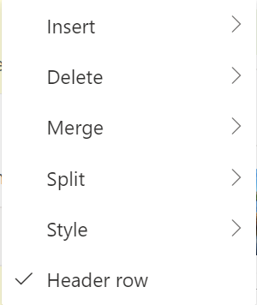
- Use predefined lists
  - Either before or after entering text, select the bulleted or numbered list icons
  - This will produce a programmatically-defined list

